Transistor BC558
CP012
Image:
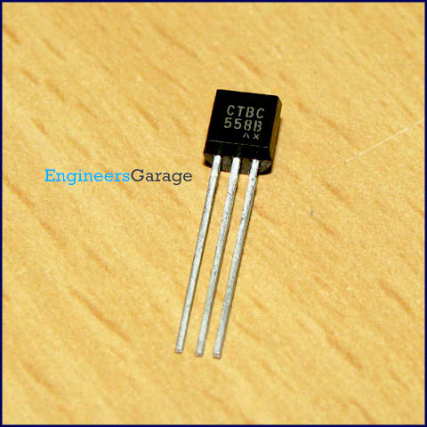
DataSheet:
BC558.PDF
BC558 is a general purpose PNP transistor. It is used in switching and amplifier applications. The DC current gain varies in range 110 to 800. It is also used as a complement for transistors BC546 to BC550.

The transistor terminals require a fixed DC voltage to operate in the desired region of its characteristic curves. This is known as the biasing. For amplification applications, the transistor is biased such that it is partly on for all input conditions. The input signal at base is amplified and taken at the emitter. BC558 is used in common emitter configuration for amplifiers. The voltage divider is the commonly used biasing mode. For switching applications, transistor is biased so that it remains fully on if there is a signal at its base. In the absence of base signal, it gets completely off.

Pin Diagram:
